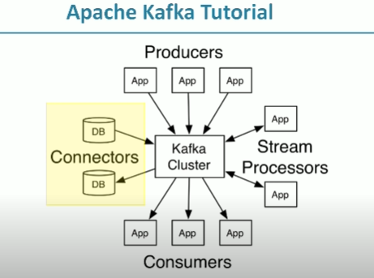

**Kafka cluster** – bunch of brokers running in a group of computers

They take message records from producers and store in kafka message log

**Consumers** - they read message from kafka cluster and process it and decide whatever it wanted to do

**Stream processors** – it will read continuous stream of data from kafka and process them, send them back to kafka or send to other systems

**Kafka db connectors** – used to import data from to kafka to db, db to kafka

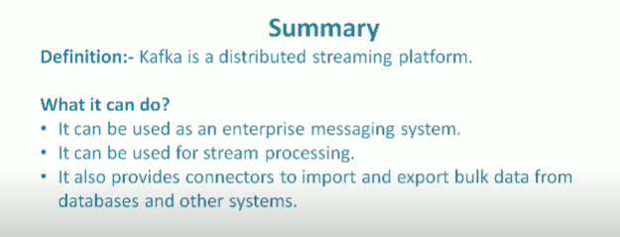

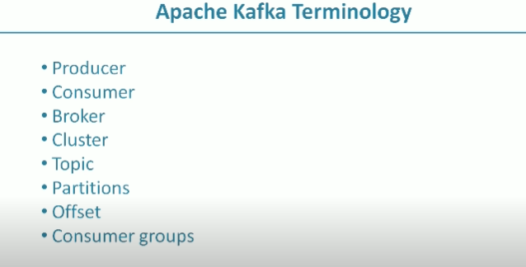

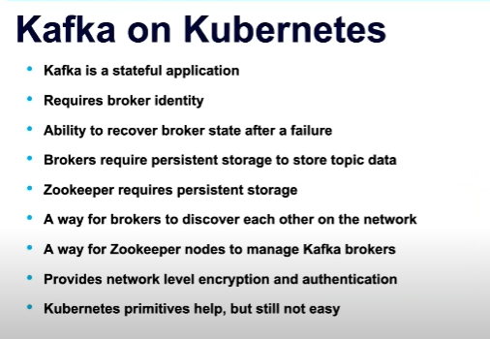

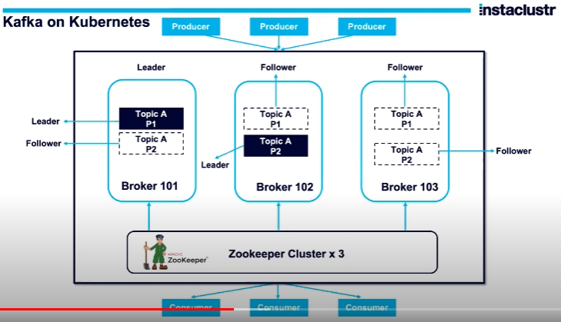

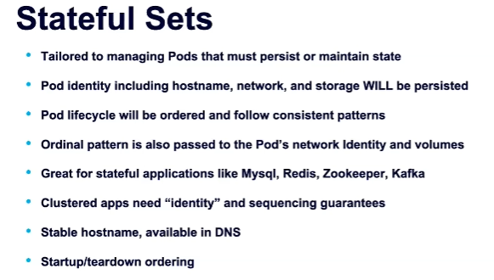

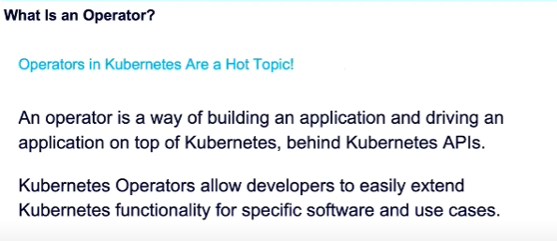

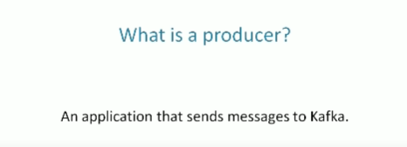

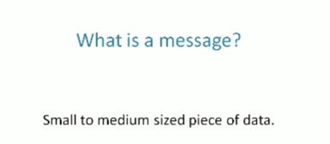

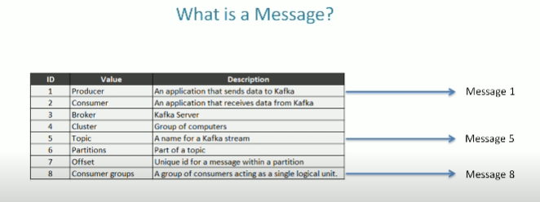

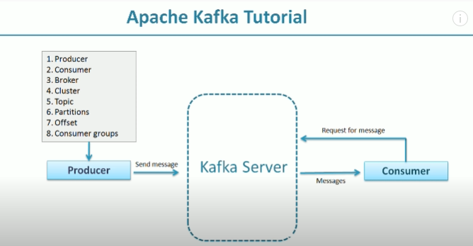

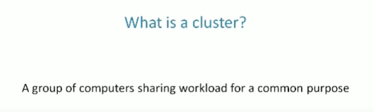

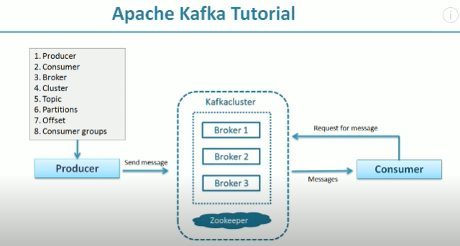

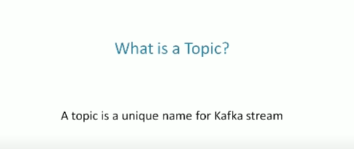

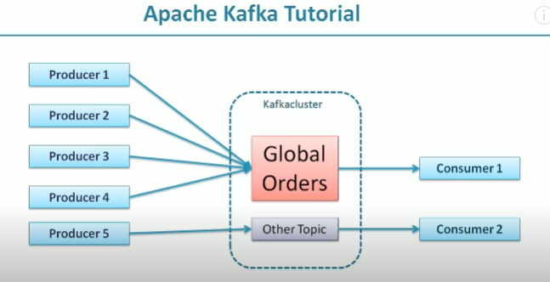

Broker would store data for a topic. If the data may be huge and large than the storage capacity of single computer. So, broker has challenges to store the data. So, it breaks the data into 2 or more parts and distribute to multiple computers

Kafka is a distributed system runs in no of system, so it stores the partition in different systems in the cluster

If the topic(data) is large how kafka knows to create how many partitions?

It was done by us, we decide how many partition have to create and kafka broker will create the same

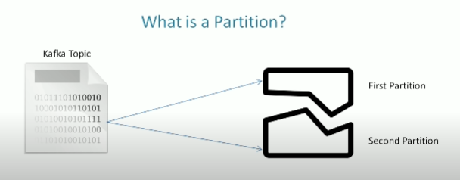

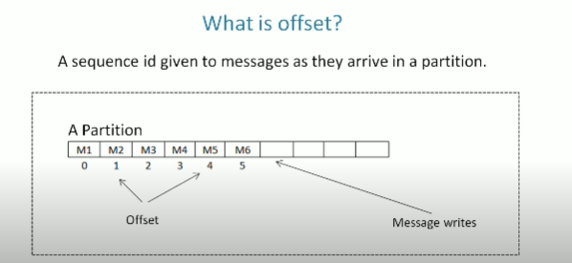

Once the no assigned, they can’t be changed

If you want to locate a message you need 3 things

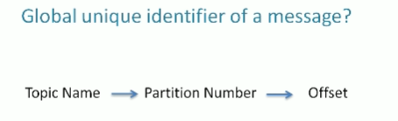

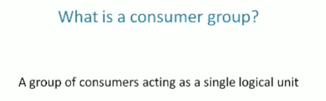

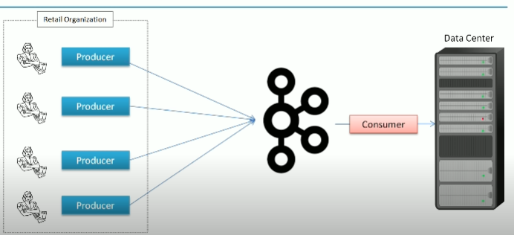

Here a retail org wants to send all its billing info to the common point

Here we must create producer in each location (shops) and create a topic at kafka and create consumer it will read data from kafka topic and write them into the datacenter

Now the problem is you have 100 of producers pushing data into the single topic, how will you handle the volume and velocity?

* Create a large kafka cluster and partition your topic

Now your topic is partitioned and distributed across the cluster, now several brokers are sharing the workload to receive the data

In the source side we have no of producers and cluster to share the work load what about the destination side ?

2.create a consumer group and start executing the group and tell them to divide the work

How do we divide the work ?

We have 600 partition and 100 consumers so each consumer can take 6 partition, if not we can add consumers upto 600 in same group

**Partitioning and consumer group is a tool for scalability.**

**The max no of consumers in the group is the total no of partitions you have on the topic.**

**Kafka doesn’t allow more than 2 consumers to read from the same partition simultaneously to avoid the double reading of records.**

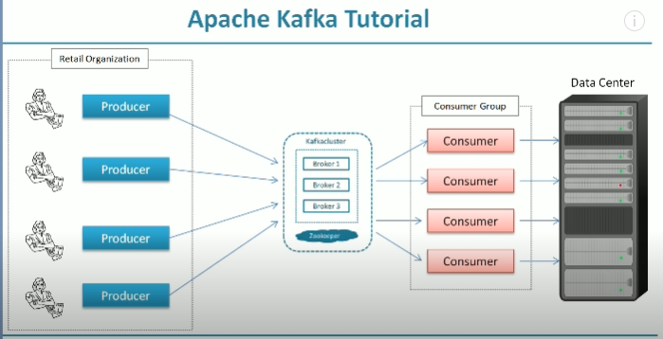

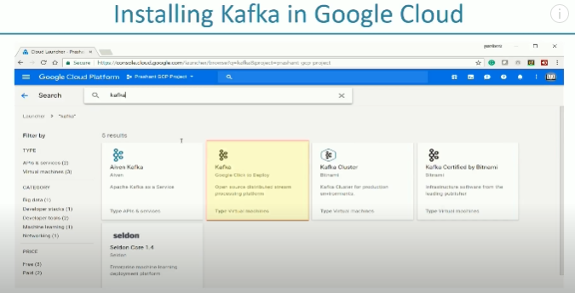

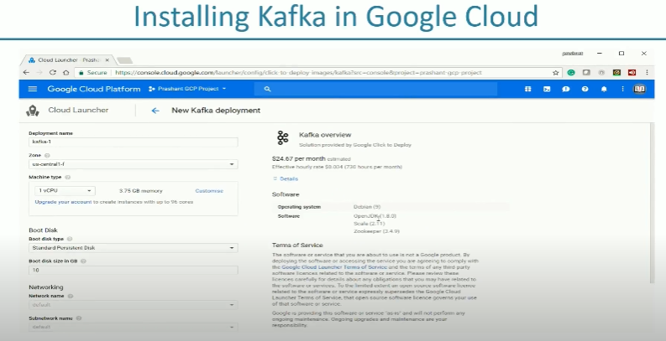

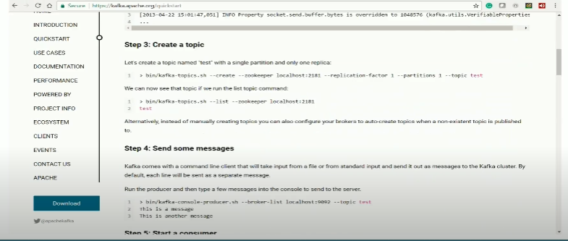

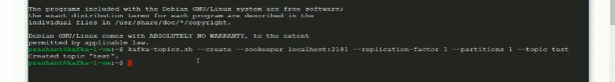

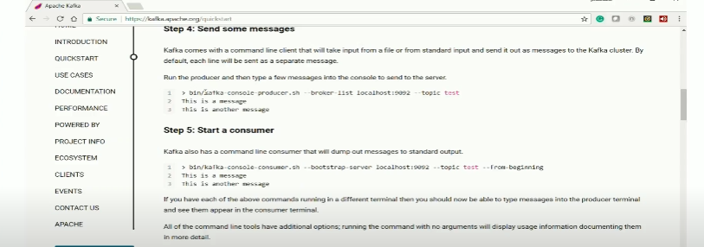

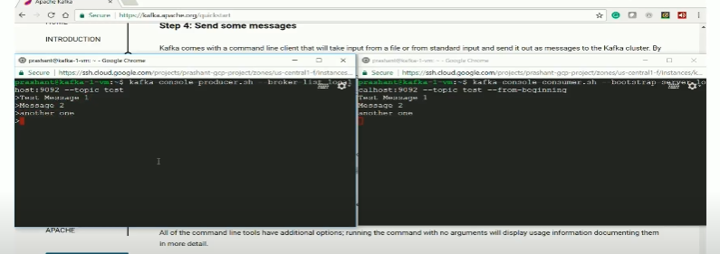

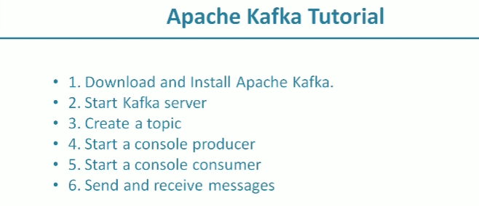

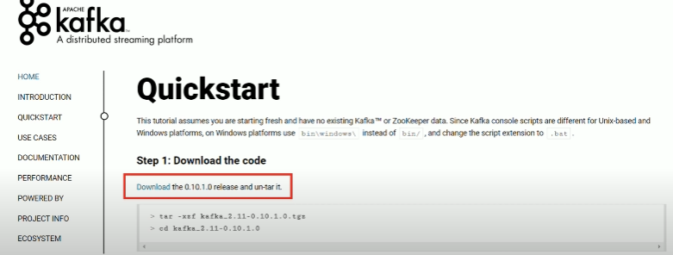

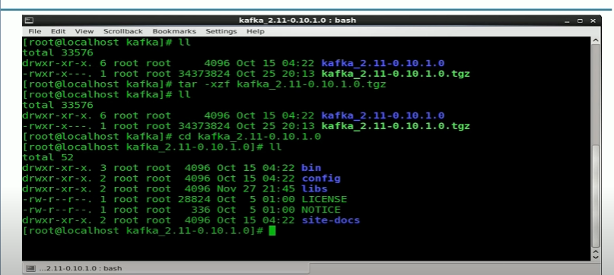

First start kafka broker before that we must start zookeeper which is used by kafka

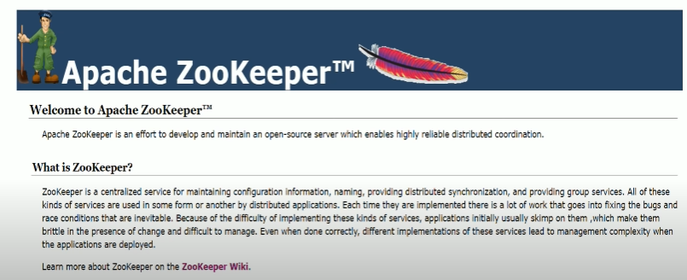

Zookeeper is Used to provide coordinated services for a distributed system

Since kafka is a distributed system and we have multiple brokers, so we need a system to coordinate various things among these brokers, so we need zookeeper for this



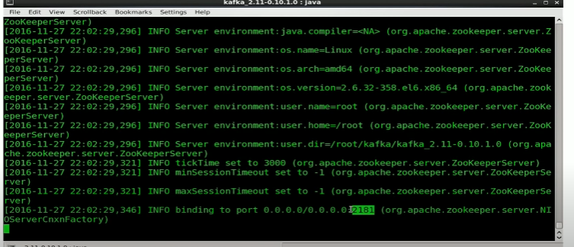

Remember this port no and start kafka broker now

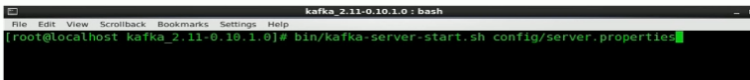

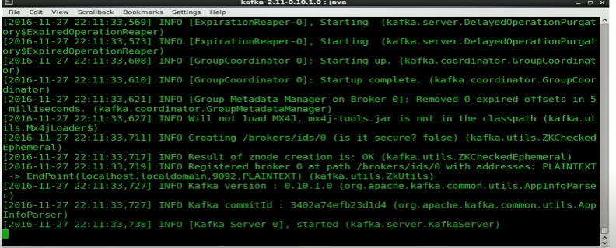

Create kafka topic now or you can skip by default kafka will create a topic for us

But we create a topic using topic management tool

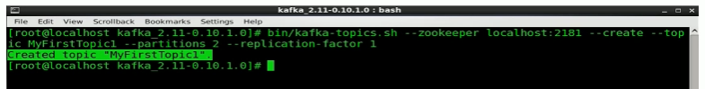

Mention zookeeper hostname and port create topic topic name and partition

Now create console producer and console consumer

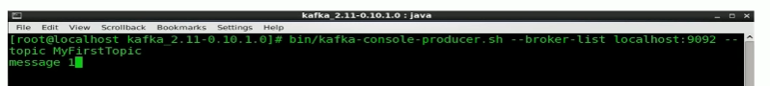

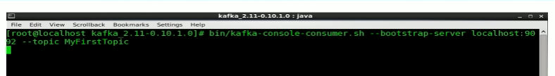

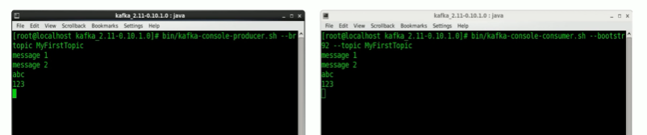

In Realtime you won’t use the console , you will use producer and consumer api and code them according to your needs

Fault Tolerance

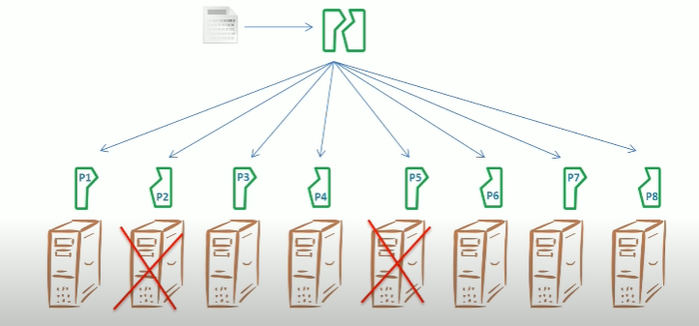

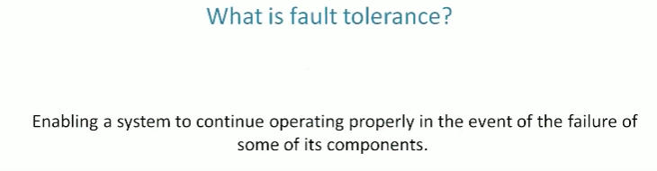

To avoid this, create multiple copies of data and keep it in separate systems

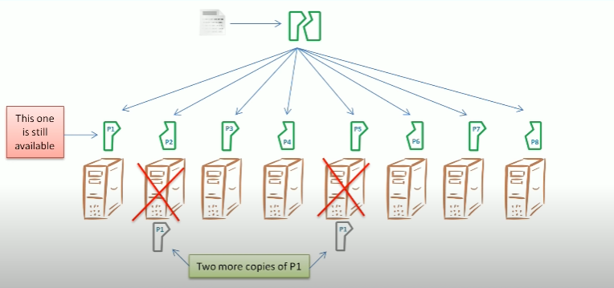

P1 has 3 copies stored in 3 systems even any 2 crashes one will available

It is called replication factor. if we specify the replication factor as 3 it will have 3 copies of p1

Kafka implements fault tolerance by applying replication to the partitions

**We can define RF in a topic level, and it applies to all partitions within the topic**

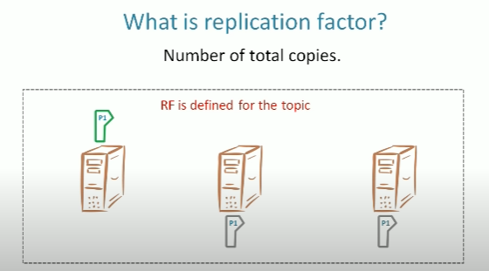

How it works?

Kafka follows leader follower mechanism here each partition has one leader and follower

The leader will read and write the data in the disk i.e. gets data from producer and sends ack to the sender and giving requested data to the consumer

Every partition has leader, it will take care of all request and response

If we create a topic with rf 3 the leader will maintain the first copy, kafka will identify the two more brokers (followers) to keep the copies

These followers will copy the data from the leader

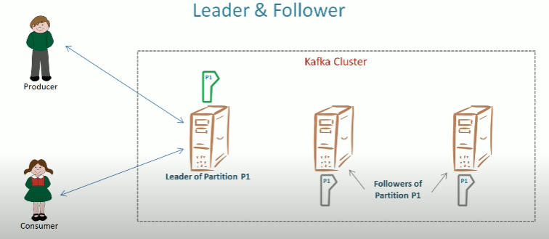

Create 3 node broker for this demo, copy the existing first broker file and edit it to create next 2 brokers(followers)

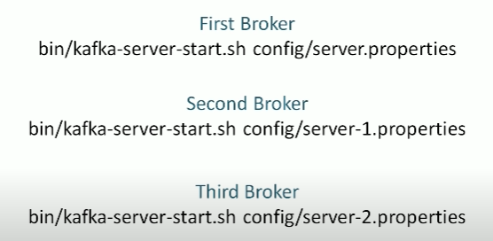

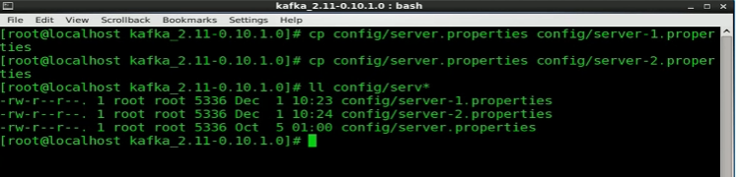

Now we have to change 3 properties in these files

1.broker id



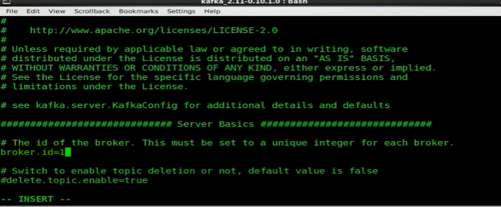

By default, first broker id is o for first broker, now edit second broker as 1 and third as 2

2.listerner port, you don’t need to edit it for if you have separate broker in each node, edit if you run 3 brokers in the same node

It is the port where the producer and consumers were listening

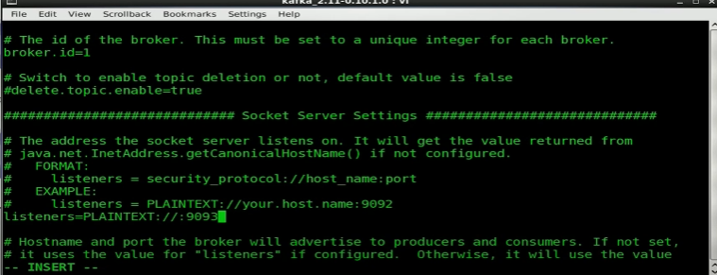

3.Broker log directory, it is the main data dir for the broker

We don’t need all brokers will write in the same dir

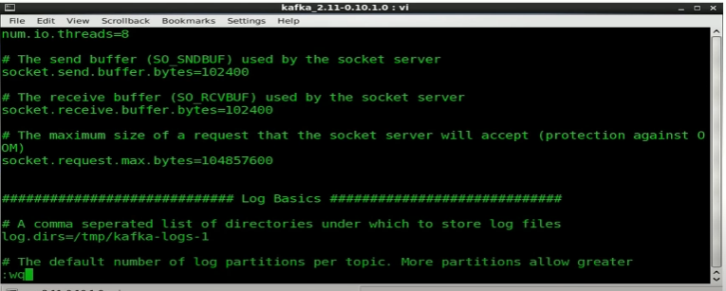

Do the same for other properties file

Start the brokers



Now create a topic with rf 3 and show the leader and follower for each partition

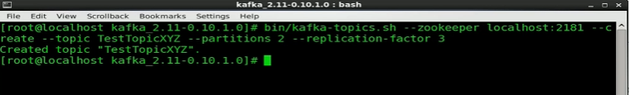

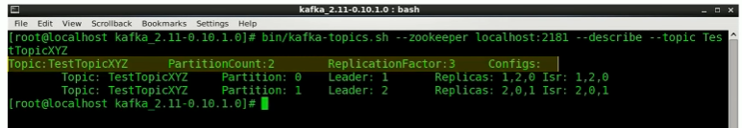

Isr – in sink replicas replica : 1,2,0 (replicas of broker 1 2 3)

# Broker Configurations

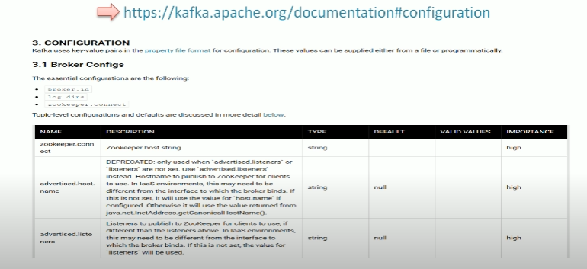

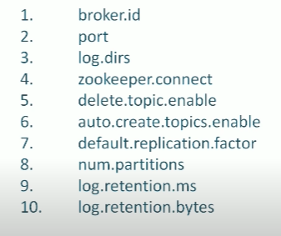

**1.zookeeper connect**

This parameter takes zookeeper connection string, connection string is simply a hostname with port no

Kafka uses it for coordination purposes, it is critical that every broker knows the zookeeper address this parameter solves that issue also it is necessary to form a cluster

Brokers are running in different systems how they know about each other? zookeeper connects it all.

**2.delete topic enable**

If you want to delete a topic, use topic mgmt. tool. But by default, it is not allowed.

You can’t remove the topic because the default value of its false

Setting this parameter to true enables you to delete the topic

**3.auto create topic enable**

If a producer is start sending messages to a non-existing topic kafka will create a topic automatically and accept data.

But not suitable for prod env so set it to false and create topic manually usinh topic mgmt. tool

**4. default replication factor and num partitions**

The default value for both is one and effective when auto create topic are enabled

If kafka is creating topic automatically the new topic will have only one partition and a single copy

**5.log retention ms and log retention bytes**

Whenever you send any data to kafka it won’t save the data, it’s not a db

But it offers a retention time and days

Default option is retention by time and retention period is 7 days

Kafka will clear all messages older than 7 days

To change this duration, change this parameter through size (applies to partition) and time

**PRODUCER API**

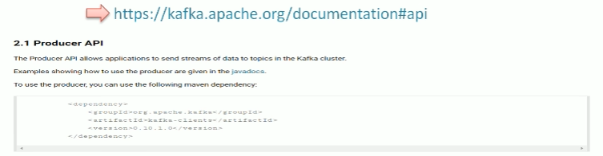

Package that defines apache kafka api

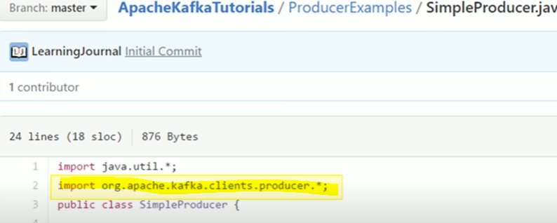

Kafka uses key value pairs, for every message you can send a key but the key is not mandatory

Sending message to that topic mentioned

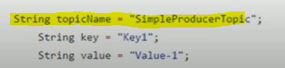

3 steps are important here

**1.create kafka producer object**

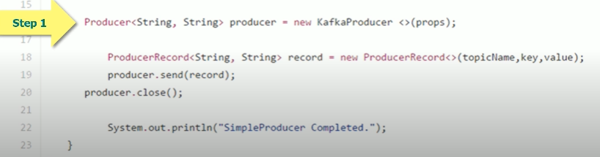

For this you need properties object<>(props) with 3 mandatory config

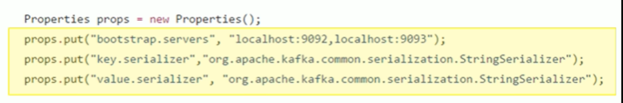

Bootstrap servers are kafka brokers, the producer object use this list to connect with kafka brokers at least 3 brokers

Next 2 properties are kafka message (the data we send is string but kafka accepts only array of bytes) so we need class convert this key into array of bytes for that in java we use serializer

Here we used string serializer also other serializer are there



Type of key and type of value

If you change data type of key and values, you should change this too

**The producer is initiated now the producer need to send some messages so**

**2. create producer record object**

It requires 3 things

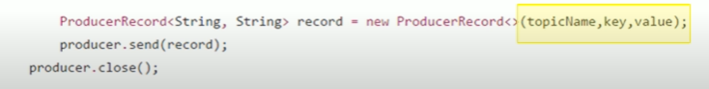

We are passing all these 3 things into a constructor and initiate the producer record

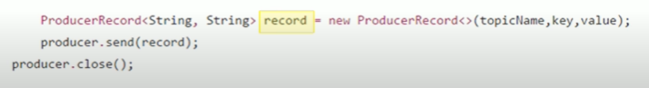

This object is our message and it should be given to producer, so the producer can send it to kafka broker

**We make a call to send method to producer object and hand over the record object.**

**Now it is producer responsibility to deliver the message to the broker**

**3. send the record to the producer**

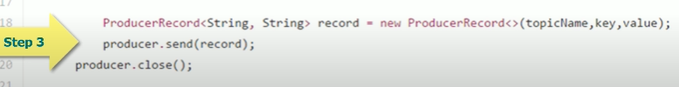

**Once all message is delivered close producer object**

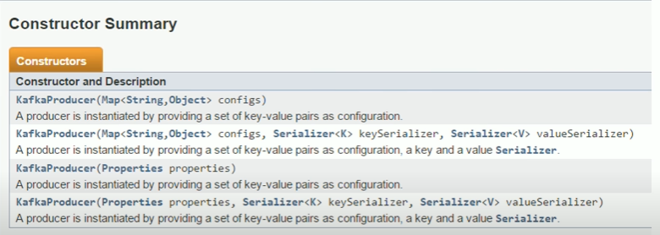

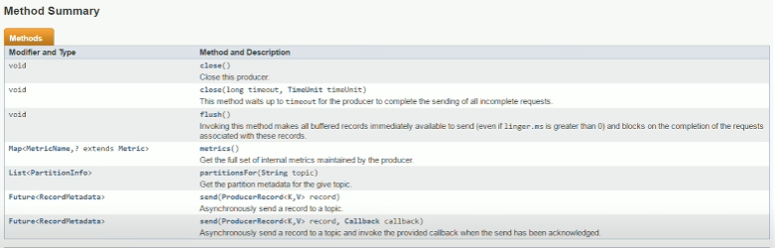



**This metadata is a kind of ack to the broker it contains message id,partition id,and offset no where the no resides.**

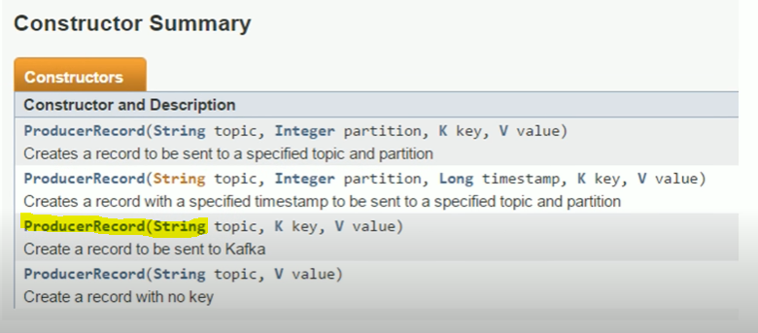

**Producer workflow**

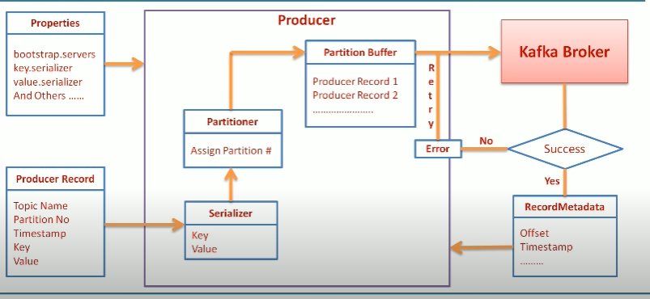

**Callback and management**

**3 methods to send message to kafka**

**1.Fire and forget**

Send msg to broker and don’t care whether the msg is successfully sent or not

**2.synchronous send**

Send a msg and wait until we get response, is success we get record meta data object, if failure we get exception

But this method is slow, drains throughput

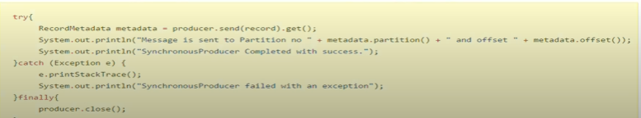

**3.Asynchronuous send better throughput**

Send a msg and provide a callback to receive ack. We don’t wait for success and failure.

The producer will callback our function with record metadata and an exception object.

If exception is null don’t do anything, if not null then it is failed

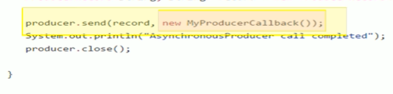

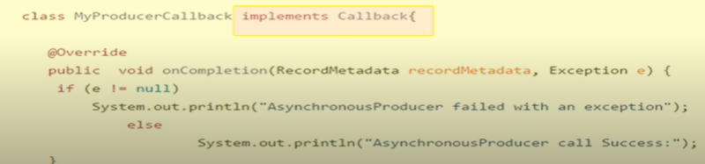

**There is a parameter to limit the configuration**



**Custom partitioner**

It is responsible for deciding partition no for each message.

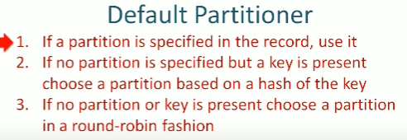

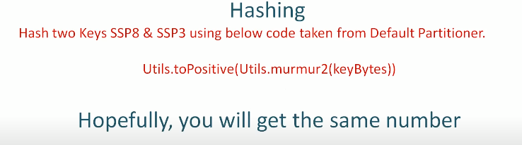

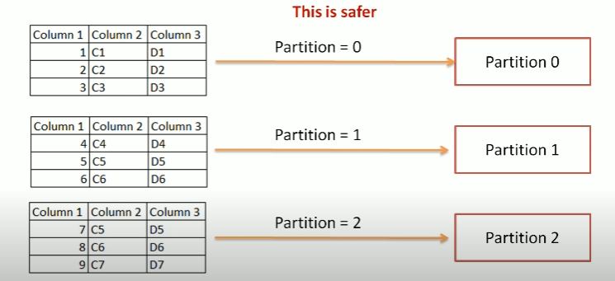

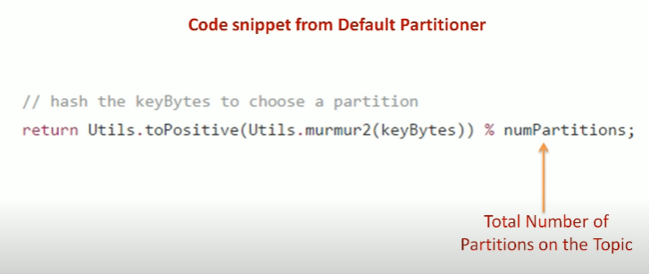

Go for custom partition

We are setting 2 property

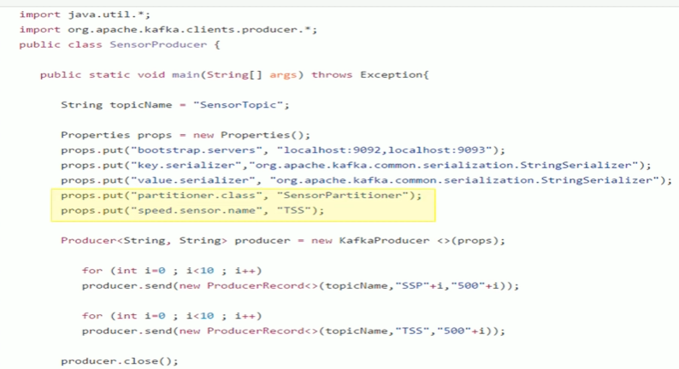

Custom Partition class (it has separate code)

Implement 3 methods in the class

Configure method, partition method and close method

Config and close methods are like initialization and clean up method

Initialize things in config and close things in close method

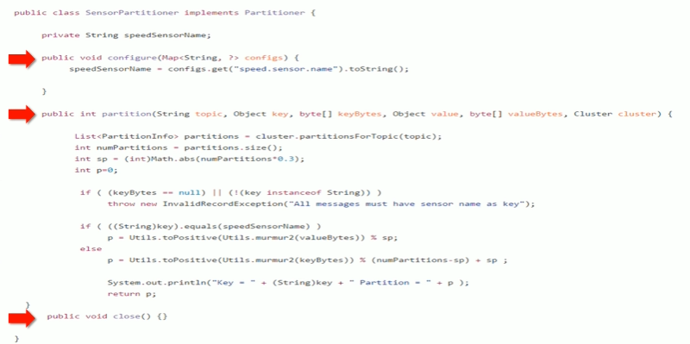

**Here our scenario is to find out the sensor name that requires 3 partitions, our producer sending this name as custom config**

**This line extracting the config value and setting it to a pvt variable so we can use it later**

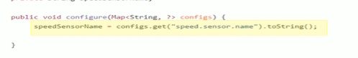

**Partition method. is the place where all action happens. The producer will call this method for each message and provide all details in every call.**

**Input to the method is**

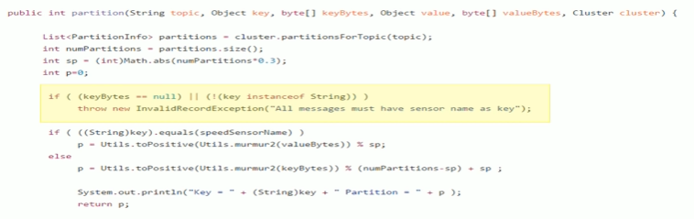

**Custom serializer**

**We need appropriate serializer for key and value by default we use key and value also we have other type of serializer kafka provide**

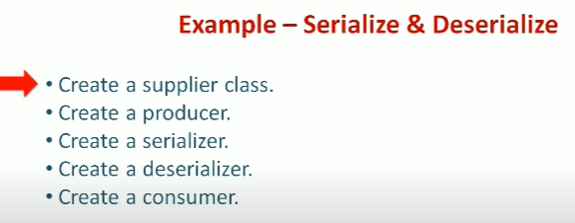

Supplier class

It defines 3 var id, name and date

Here we have 1 constructor and 3 methods in class

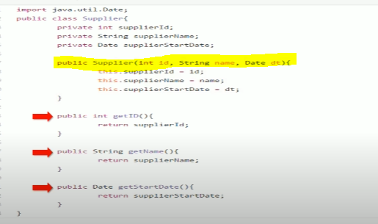

Serializer class

See in video

**Producer configuration**

**All are producer level**

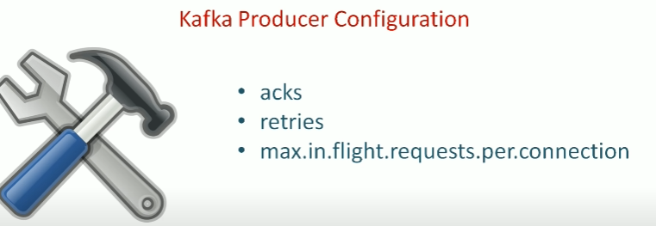

**Acks for acknowledgement**

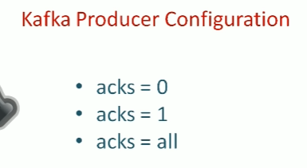

**Acks=0 don’t worry about ack it will keep send data. producer does not wait for response**

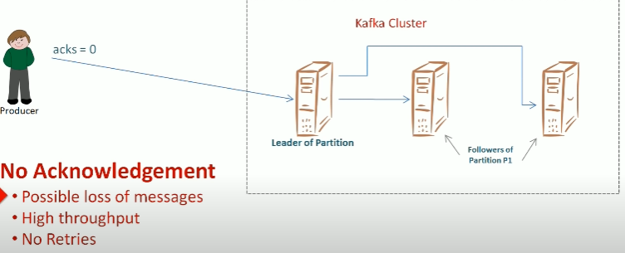

**Acks =1 producer wait for response**

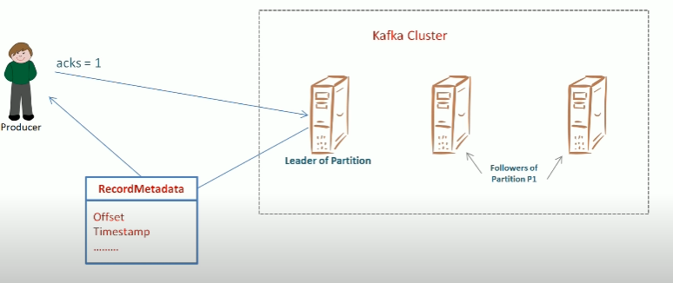

**Acks=all the leader will ack once it receives the ack from all other replication**

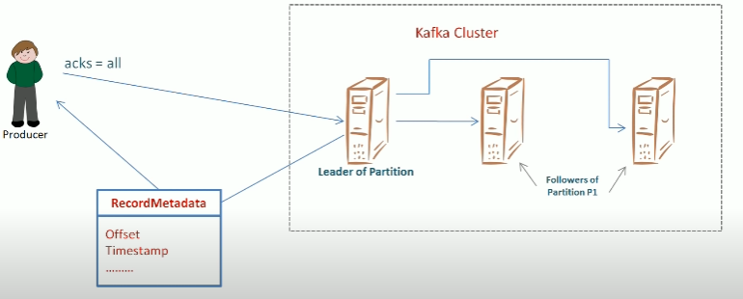

**RETRIES**

How many times the producer will retry after getting an error

Default value is 0

Retry.backoff.ms that control the time between 2 retries

Default val is 100ms

**MAX.in.flight.requests.per.connnection**

**Consumer groups**

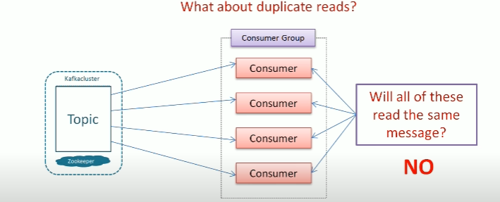

**One consumer owns a partition at any point of time**

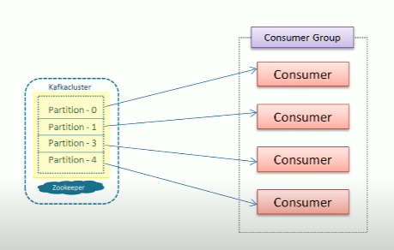

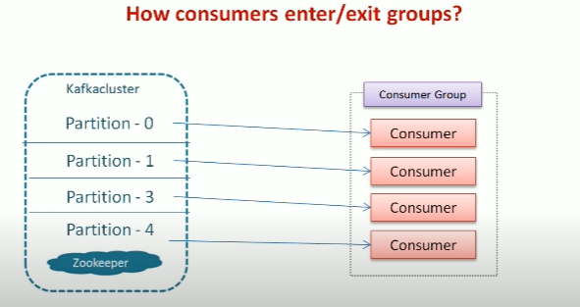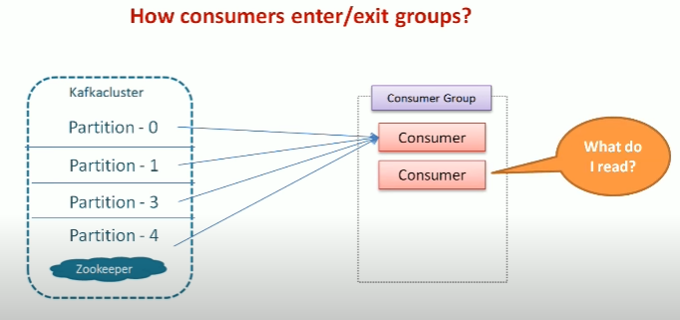

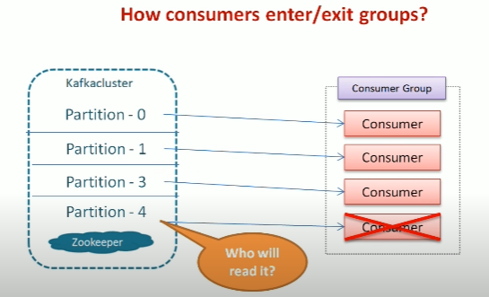 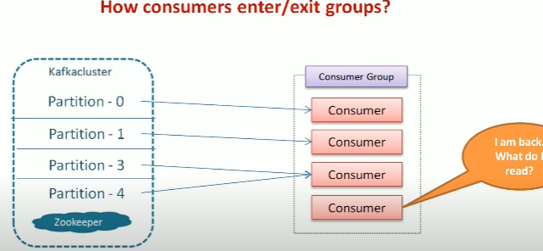

In a live env consumers keeps joining and exit we don’t have control on it ? how kafka handles it ?

When a consumer joins a group ? how a partition assign to it ?

What happens to the partition when a consumer leaves a group ? who manges all these ?

Group coordinator will manage all these

One if the kafka broker elect as group coordinator , when consumers wants to join a group it sends req to the co ordinator

The first coordinator participate in the group will become a leader , others are members

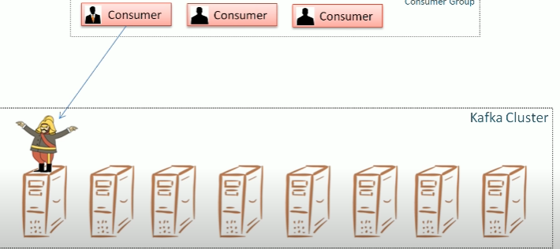

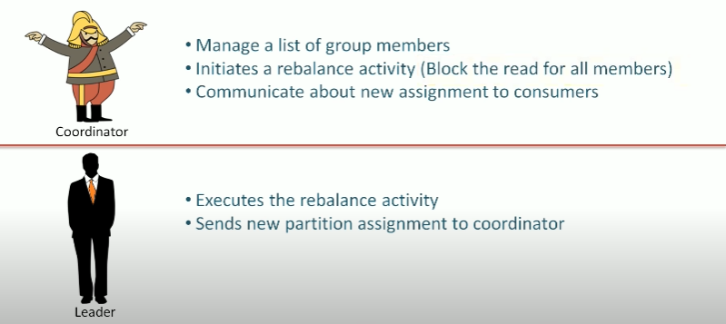

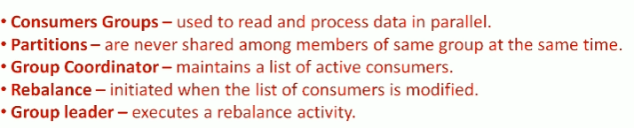

Rebalance activity is assigning partitions to the individual conusmers

You no need to create group , group id separately? No just specify the group name in string

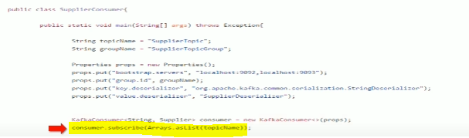

You can subscribe a topic in consumers also you can subscribe more than one topic

Once you subscribed to a topic you need to fetch data from the topic so,use this while loop to fetch the data. The poll method fetches the data and process and also return to fetch the data back

Its also timeout sec when no data is there

When you call a poll for the first time from a conusmer it finds a group coordinator joins the group,receives partition assignment and fetches some record from those partitions.

Every time you call the poll it sends heart beat to the group coordinator, if you don’t poll the coordinator will assume the consumer is dead and trigger partition rebalance

Keep the properties file separately instead of having them in same file

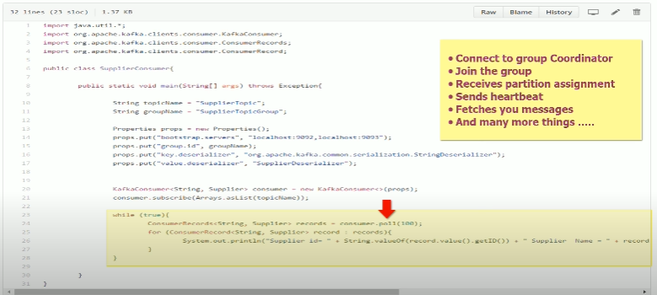

Offset

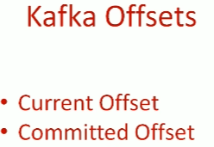

Offset is a simple integer no used by kafka to maintain the current position of a consumer

So the consumer wont get same record twice

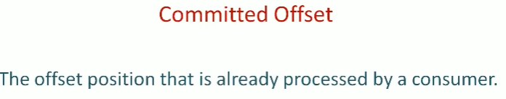

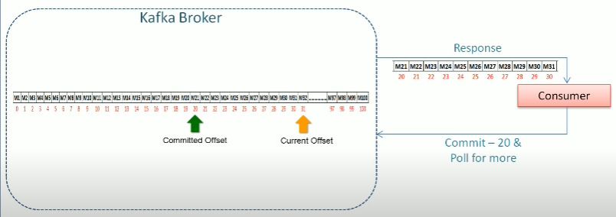

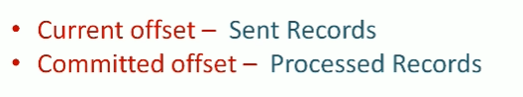

Current offset is used to avoid resending the same record again to the same consumer

Comitted offset is used to avoid resending the same record again to the new consumer in the event of partition rebalance.

How to commit offset ?

Manual and auto

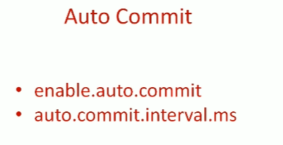 auto commit is enabled by default you can set it to false to off

Second one defines the interval of auto commit

Default value 5 s

AUTO COMMIT

You have some msg in aprt , you send apoll req and the partion returns data to the consumer with 10 offset in 4 secs

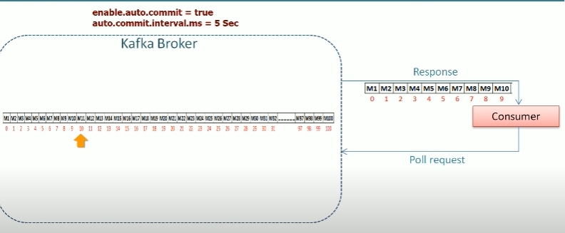

Bur value is 5 secs you didn’t complete the 5 secs the consumer will not commit the offset

You receive another set of records , for this reason rebalance is trigerred at this moment

First 10 recorda are already passed but didn’t comitted yet and rebalnce is trigerred and the partition goes to the different consumer , since we don’t have comitted offset the new consumer will process from beginning and process first 10 record once again

You can think we can set autocommit value to 4 sec but its is not gaurnteed to process the previous data

So go for manual commit

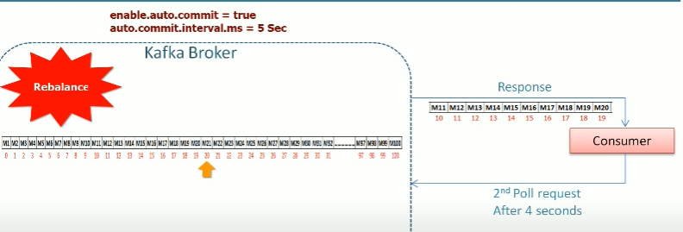

So set autocommit off and manually process the records



2 approaches

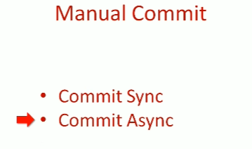

Commit sync is a reliable method but it will block your call for completing your commit operation and retries if there are any recoverable errors

Commit async will send msg continuously but it wont retry

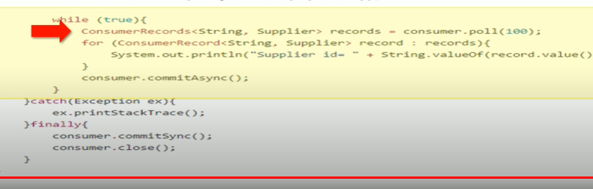

How to commit particular offset and how to rebalce listener ?

If you are processing a large amount of data there will be a delay for that you get

**Delay in next poll**. If you don’t poll for a long the group coordinator will think the consumer is dead and trigger a rebalnce activity. But we don’t want that to be happen the consumers are not dead it is computing

Next risk is **rebalance trigger** , if the coodinator is trigerred for other reason when you compute large data

In both scenarios rebalce is trigerred either you process data long or something went wrong the partition will be assigned to the new consumer

In such conditions you need to commit before the partitons is taken from you

For this you need 2 things

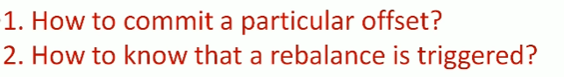

2 ans kafka api allows us to specify rebalacer listener class it has 2 methods

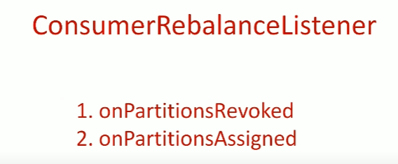

Api will call onpartitionsrevoked method just before it takes away your partition so this is where you can commit your current offset

Api will call onpartitions assigned right after the rebalance is comittedand befor you start consume records from the new partitions

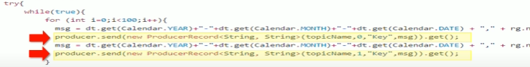

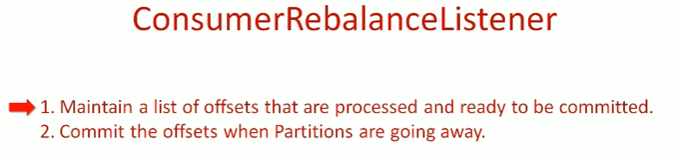

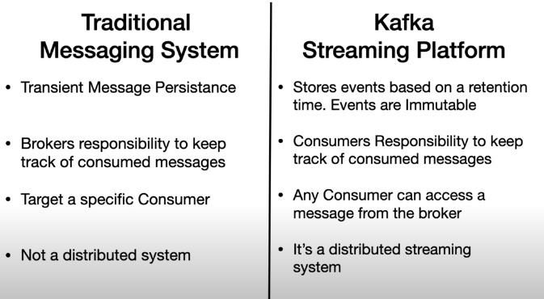

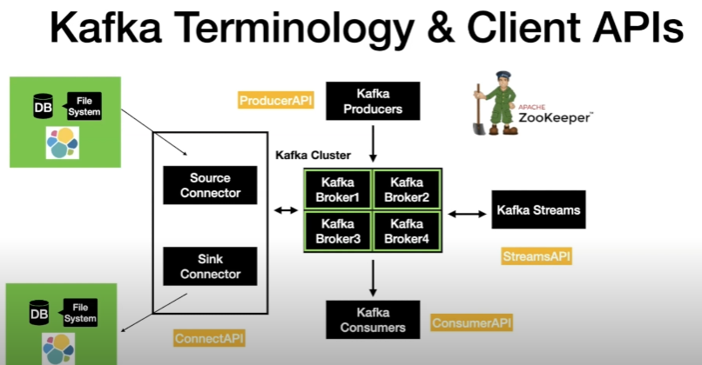

Source connector

Is used to pull the data from the external source like DB, filesystem or elastic search into the kafka topic

Sink connector

Opposite of source is sink connector

With **kafka connect(or)** you can perform the data movement in/out of kafka without writing a single line of code

Streams API

Used to take data from kafka and perform simple to complex transformation on it and put it back to kafka

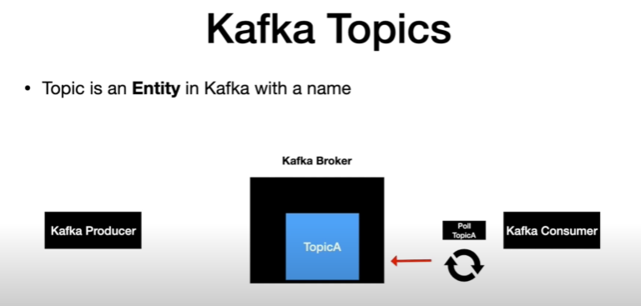

Producer send messages to topic

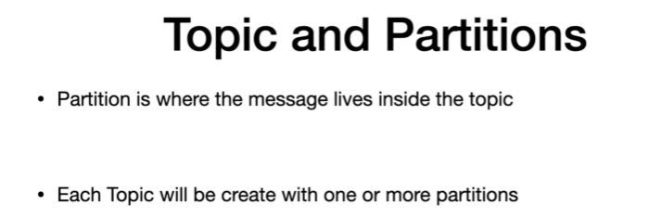

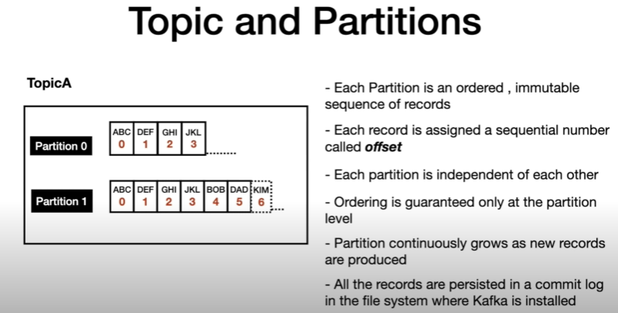

When producer send message to a topic and topic to partition o its offset is incremented by one

Same way as partition

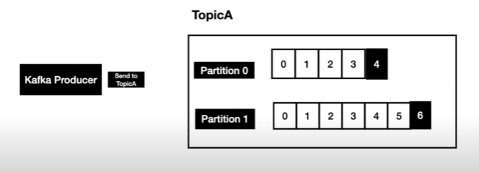

**Producer has a complete control on which partition the message is going to go**

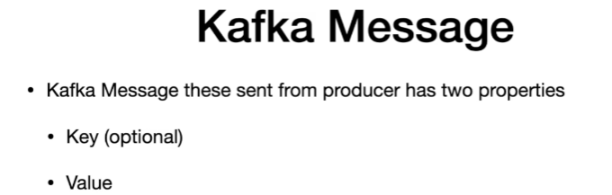

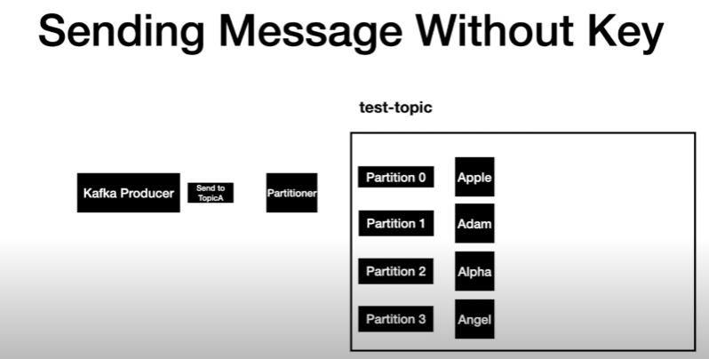

Partitioner is programmable, it decides where to send data to the which partition generally it used round robin

With key all messages send to particular partition can be done by partitioner using hasing technique

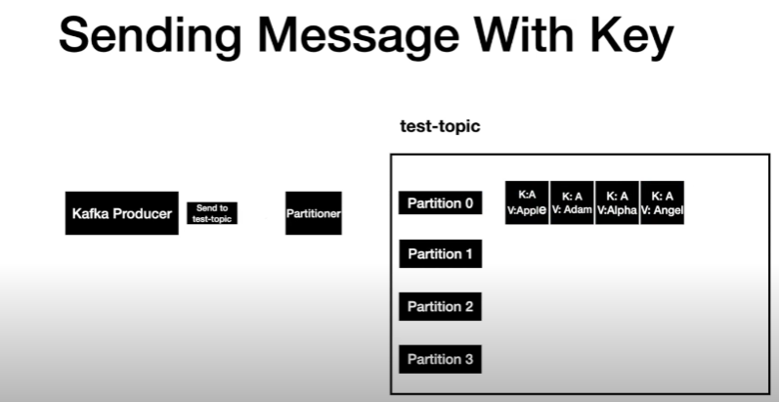

Same key always resolves to the same partition

## How to instantiate a Console Producer?

### Without Key

kafka-console-producer.bat --broker-list localhost:9092 --topic test-topic

### With Key

kafka-console-producer.bat --broker-list localhost:9092 --topic test-topic --property "key.separator=-" --property "parse.key=true"

both are same but two parameters are different key separator and parse key while passing these parameters the console producer will read these keys and produce message with key

## How to instantiate a Console Consumer?

### Without Key

kafka-console-consumer.bat --bootstrap-server localhost:9092 --topic test-topic --from-beginning

### With Key

kafka-console-consumer.bat --bootstrap-server localhost:9092 --topic test-topic --from-beginning -property "key.separator= - " --property "

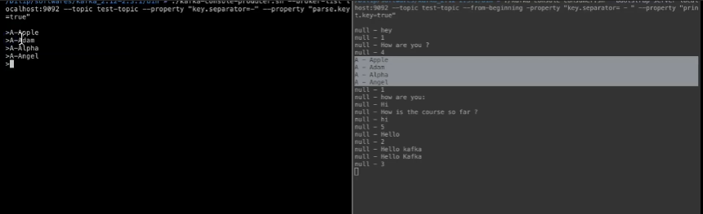

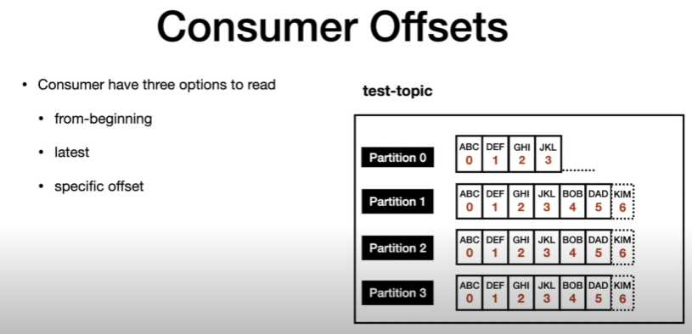

These options can be done programmatically, you can perform all these actions when you start consumer

First 2 can be exclude using the console consumer itself

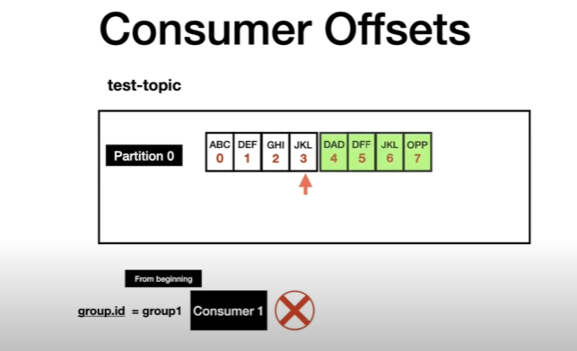

When you send a message, consumer is down after that consumer is up how does it know about new message

Consumer offset are in general to store in an internal topic

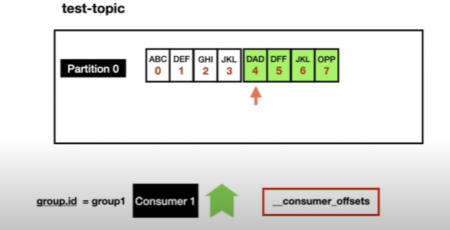

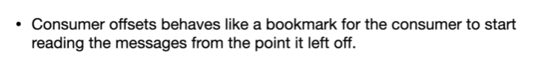

## List the topics in a cluster

kafka-topics.bat --zookeeper localhost:2181 --list

## Describe topic

* The below command can be used to describe all the topics.

kafka-topics.bat --zookeeper localhost:2181 --describe

* The below command can be used to describe a specific topic.

kafka-topics.bat --zookeeper localhost:2181 --describe --topic <topic-name>

## Alter the min insync replica

kafka-topics.bat --alter --zookeeper localhost:2181 --topic library-events --config min.insync.replicas=2

## Delete a topic

kafka-topics.bat --zookeeper localhost:2181 --delete --topic <topic-name>

## How to view consumer groups

kafka-consumer-groups.bat --bootstrap-server localhost:9092 --list

### Consumer Groups and their Offset

kafka-consumer-groups.bat --bootstrap-server localhost:9092 --describe --group console-consumer-27773

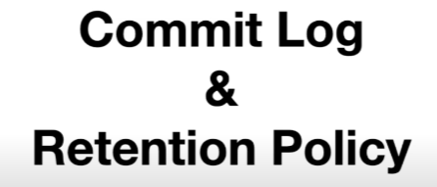

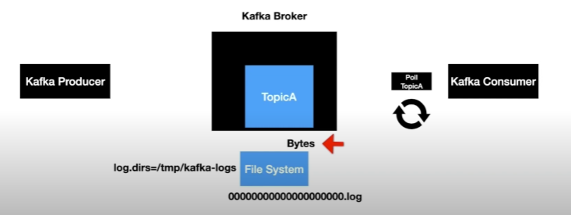

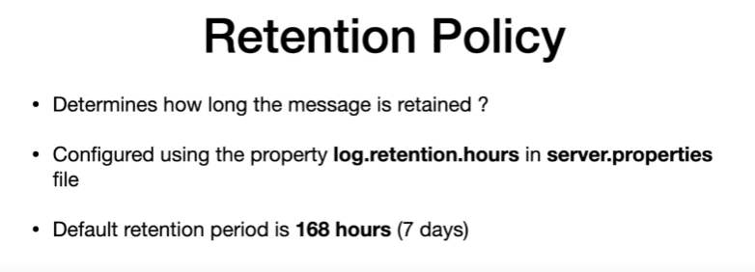

## Viewing the Commit Log

kafka-run-class.bat kafka.tools.DumpLogSegments --deep-iteration --files /tmp/kafka-logs/test-topic-0/00000000000000000000.log

# Kafka as a Distributed Streaming System

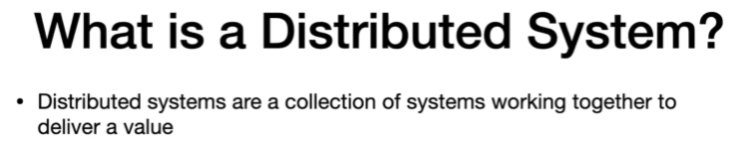

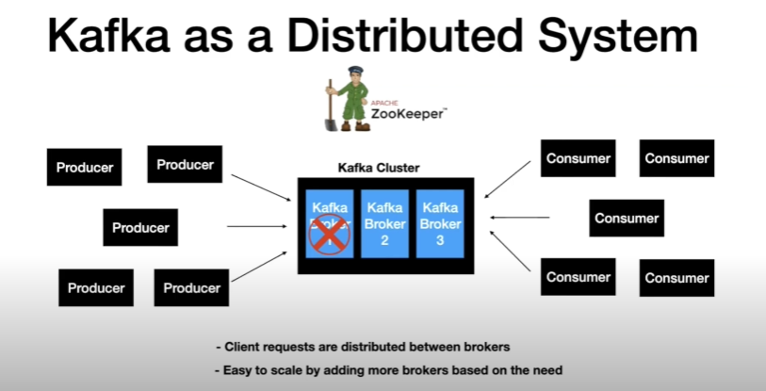

# How Kafka Cluster distributes the Client Requests between the brokers

We have 3 brokers and one of the broker is the controller bcz it is the first broker added in the cluster

So, it has an additional role as controller

Create a topic this will go to zookeeper and the zoo keeper will redirect it to the controller, the role of the controller is to distribute the ownership of the partitions to the available broker

Part1 in bro1 par2 in bro2 so on

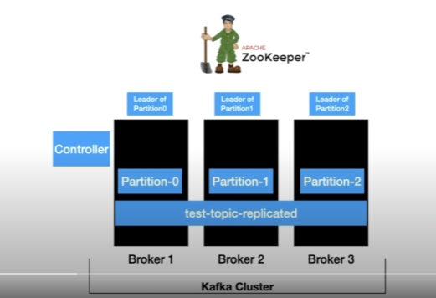

In distributed systems the concept of distributing partitions to the brokers is called leader assignment

Here the test topic is distributed across kafka cluster

How does the cluster handle the requests from clients?

Producer has a layer called partitioner it decides in which partition the message should go to

Producer sends msg to partitioner before the msg send to the kafka topic

Partitioner decides this msg go to part 0 , in this the leader of part 0 is broker 1 so msg send to broker 1

And the broker saves the msg in local filesystem

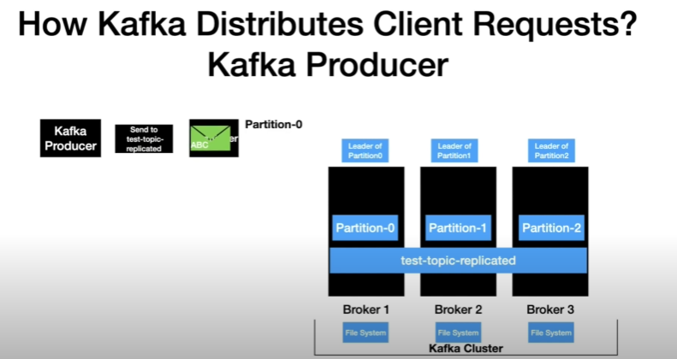

When the poll loop is executed in consumer end it will fetches the records from the kafka cluster

The poll request goes to all the brokers to retrieve the records, and the records handed to the consumer

The consumer call will go only to the leader partition of the topic to retrieve the data

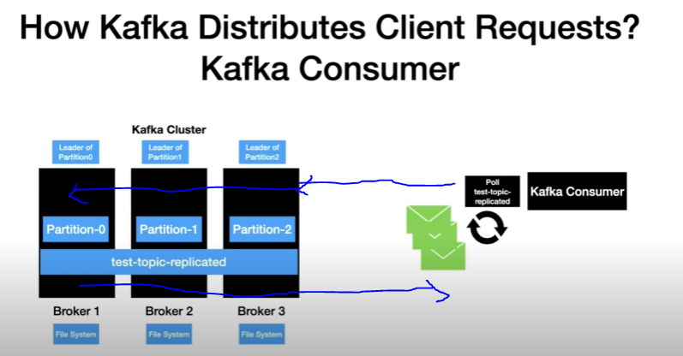

If one or more instances of the consumer with the same group id then the partitions are distributed for scalable message consumption.

Here each consumer instances have one partition assigned

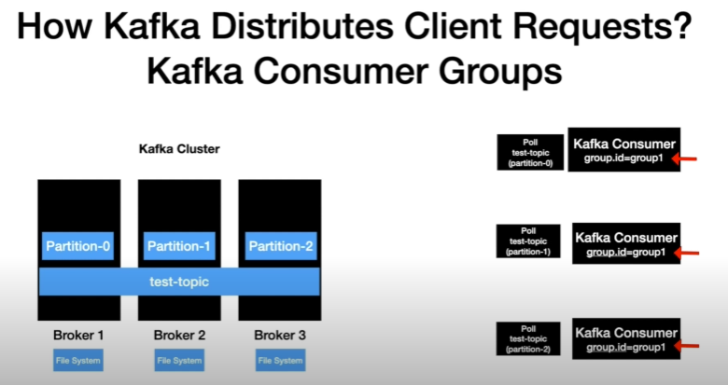

When poll loop is executed each instances will poll the data from the partition , the poll call goes to the leader of the topic and retrieves the data

Part 0 call goes to broker 1 and so on

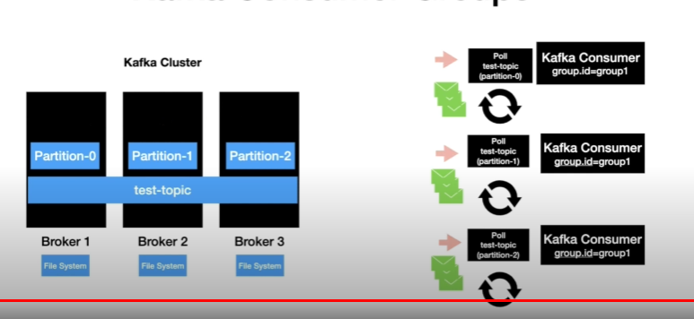

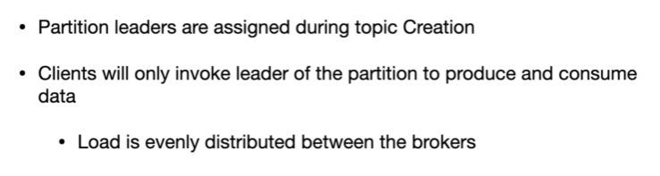

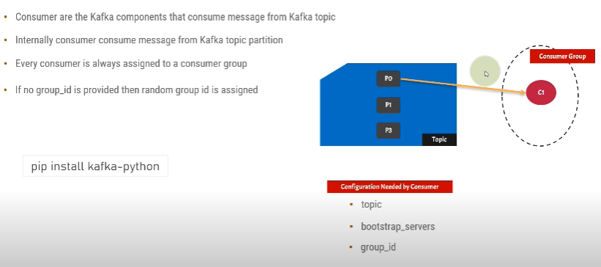

Bootstrap server – which kafka cluster where the consumer going to get msg

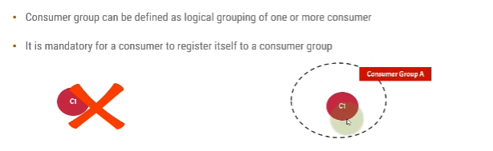

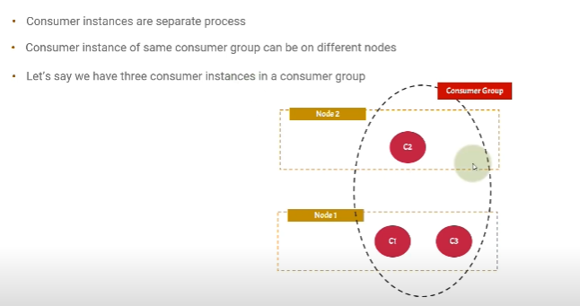

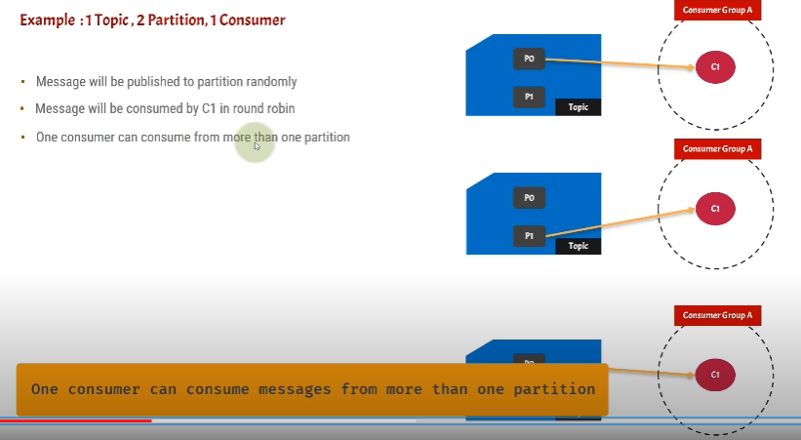

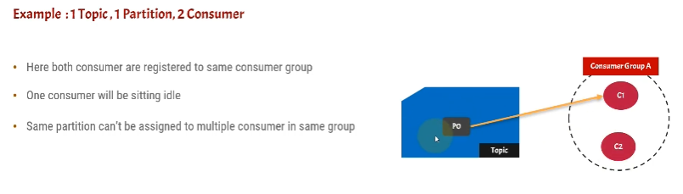

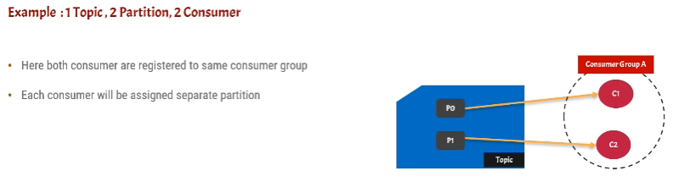

Multiple consumers in a same consumer group – each consumer will have separate partition and if you have many partition these consumers will pick it up randomly

Can multiple producers write to same Kafka topic?

**Kafka** is able to seamlessly handle **multiple producers** that are using many **topics** or the **same topic**. The **consumer** subscribes to one or more **topics** and reads the messages. The **consumer** keeps track of which messages it has already consumed by keeping track of the offset of messages.

<https://docs.cloudera.com/documentation/kafka/latest/topics/kafka_performance.html>